**KINDERGARTEN SUPPLY LIST 2025-2026**

**\*\*Please send these items to school with your child on the first day of classes\*\***

**Please label scrapbook, shoes, lunch kit, backpack, family photo**

1 Large backpack, 1- lunch kit to carry their snack items

1 4” X 6” family photo

1 FISKARS scissors - 5” blunt

1 Package stickers

3 UHU brand glue sticks 21g (yellow with white cap)

1 Box of 3 ply Kleenex

1 Pkg. of Wet Wipes

1 Box Large Ziploc Bags

1 Hilroy brand 20-page coil scrapbook 35x27cm (blue cover – see picture below)

1 Package black “tri-conderoga” pencils (see picture)

4 Black Expo Low Odour Markers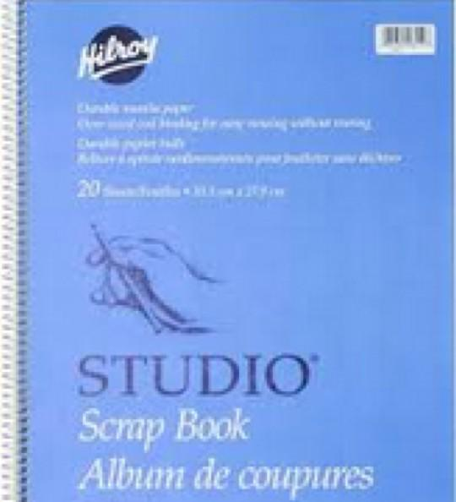

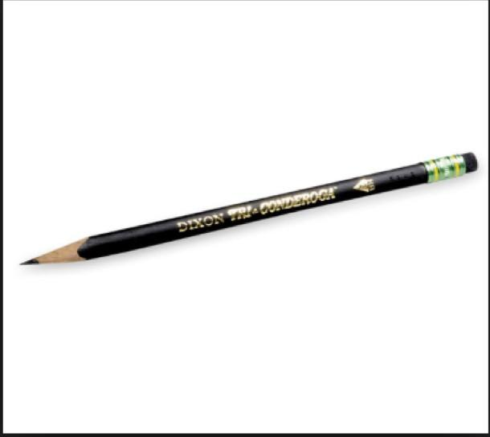

**A “*just in case*” bag in the backpack. (large zip plastic bag with an extra pair of pants and underwear. Please write your child’s name on the bag)**

**Reminder to also send:**

* One pair of indoor running shoes with non-marking soles. Please mark your child’s name on the shoes.
* **Please ensure your child can put their shoes on independently.**
* **Please do not send shoes with laces unless your child can tie their shoes independently.**